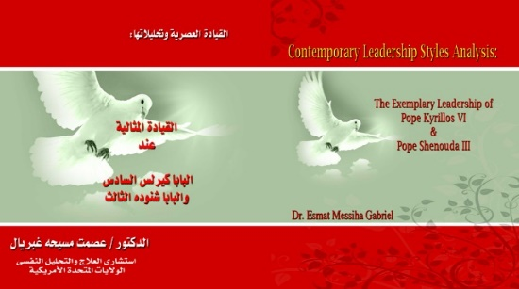

**The Exemplary Leadership of**

**Pope Kyrillos VI & Pope Shenouda III**

By

Dr. Esmat M. Gabriel

*Book Prominent Attributes:(Available in Arabic)*

Pope Kyrillos VI (Cyril VI), born in August 8, 1902 was the 116 Pope of Alexandria and Patriarch of the See of St. Mark (1959 – 1971). His Leadership style was unique and spiritual characterized by paternalism that manifested the fruit of the Holy Spirit. A servant-leadership style that was distinctly Christ-like. As a result, his approach to solve long awaited and unresolved cases in the Coptic Orthodox Church was through a compassionate strategy. His Holiness empathetic approach might not carry a title at that time but the practice and execution of the plan and its results would describe such leadership as compassionate ***“transactional leadership.”***

Along with this well-known style of ***paternalism,*** he adopted what became evident as ***“Delegative Leadership.”*** This leadership approach, the leader does not make every decision but he steps into whatever situation and share his vision for better solution and better future. That was how Pope Kyrillos accomplished his mission. As an elected and heavenly selected spiritual leader, he delegated to trustworthy others to execute his vision and action plan and supported its fruition. The empowerment behind these marvelous deeds and performance was Divine Providence. He was truly an anointed and humble ascetic monk who became a Pope but never departed from living the hermit life devoted to prayers and celebrating divine liturgy every day even during his papacy.

The Coptic Church as an institution was hard to reform and embrace what was required to meet the challenges of the twentieth century’s technical and scientific knowledge. With fear of the unknown, the persistent and rigidity of thoughts of the old guards lingered for decades.

Amazingly enough, Pope Kyrillos’ leadership role went far beyond the Coptic Church’s culture transformation by preparing her to meet the demands of the 20th century modern life. He shepherded families and/or individuals everywhere on the globe that sought his prayers, and blessings. Empathically shepherding all regardless of their religion, ethnicity, or creed. His “Open-door” policy permitted anyone to visit for healing, problem solving or for seeking His Holiness’ saintly prayers that “eminently and miraculously” answered. On June 2013, he was canonized as a saint by the Holy Synod of the Coptic Orthodox Church.